**Introduction to Bootstrap**

**Lab report #03**



Fall 2023

CSE-423L Web Engineering

Submitted by: **Ashfaq Ahmad**

Registration No: **19PWCSE1795**

Class Section: **B**

“On my honor, as student of University of Engineering and Technology, I have neither given nor received unauthorized assistance on this academic work.”

Student Signature: ______________

Submitted to:

**Eng. Usman Malik**

**March** 26, 2023

**Department of Computer Systems Engineering**

**University of Engineering and Technology, Peshawar**

**Task 01:**

**HTML Code:**

<!doctype html>

<html lang="en">

<head>

    <meta charset="utf-8">

    <meta name="viewport" content="width=device-width, initial-scale=1">

    <title>Bootstrap demo</title>

    <link href="https://cdn.jsdelivr.net/npm/bootstrap@5.3.0-alpha2/dist/css/bootstrap.min.css" rel="stylesheet"

        integrity="sha384-aFq/bzH65dt+w6FI2ooMVUpc+21e0SRygnTpmBvdBgSdnuTN7QbdgL+OapgHtvPp" crossorigin="anonymous">

    <link rel="stylesheet" href="Task.css">

</head>

<body>

    <div class="text-white cont">

        <div class="row Header">Header</div>

        <div class="row">

            <div class="col-3 sidebar">Sidebar</div>

            <div class="col-9">

                <div class="row main">Main</div>

                <div class="row">

                    <div class="col-6 item1">item1</div>

                    <div class="col-6 item2">item2</div>

                </div>

            </div>

        </div>

        <div class="row footer">footer</div>

    </div>

    <script src="https://cdn.jsdelivr.net/npm/bootstrap@5.3.0-alpha2/dist/js/bootstrap.bundle.min.js"

        integrity="sha384-qKXV1j0HvMUeCBQ+QVp7JcfGl760yU08IQ+GpUo5hlbpg51QRiuqHAJz8+BrxE/N"

        crossorigin="anonymous"></script>

</body>

</html>

**CSS Code:**

.cont{

    padding: 5px 20px;

}

.Header{

    background-color: rgb(50, 10, 169);

    height: 80px;

}

.sidebar{

    background-color: blueviolet;

    height: 450px;

}

.main{

    background-color: rgb(74, 74, 156);

    height: 330px;

}

.item1{

    background-color: aquamarine;

    height: 120px;

}

.item2{

    background-color: rgb(41, 108, 85);

}

.footer{

    background-color: rgb(50, 10, 169) ;

    height: 110px;

}

.Header,.footer,.main,.item1,.item2,.sidebar{

    border: 5px solid black;

    display: flex;

    justify-content: center;

    align-items: center;

}

**Output:**

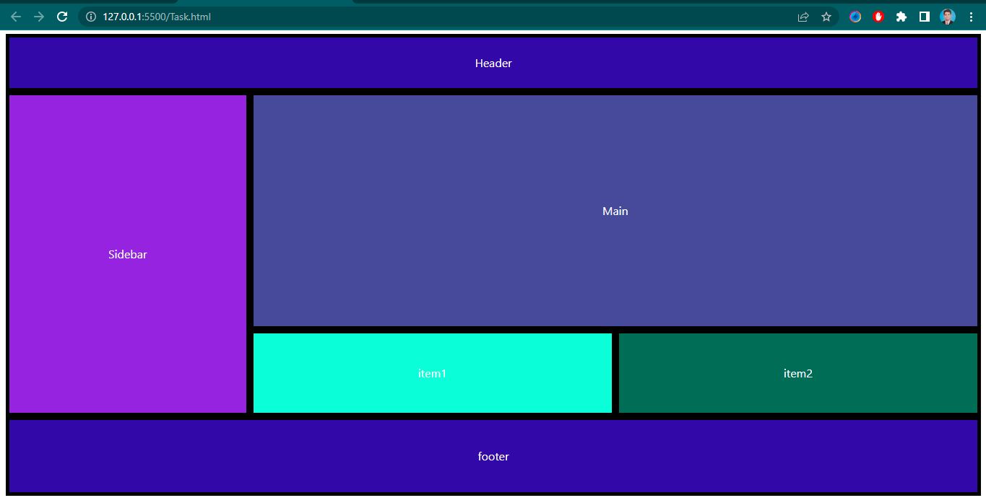

**Task 02:**

Use Bootstrap Button and Dropdown class:

**Code:**

<!doctype html>

<html lang="en">

  <head>

    <meta charset="utf-8">

    <meta name="viewport" content="width=device-width, initial-scale=1">

    <title>Bootstrap demo</title>

    <link href="https://cdn.jsdelivr.net/npm/bootstrap@5.3.0-alpha1/dist/css/bootstrap.min.css" rel="stylesheet" integrity="sha384-GLhlTQ8iRABdZLl6O3oVMWSktQOp6b7In1Zl3/Jr59b6EGGoI1aFkw7cmDA6j6gD" crossorigin="anonymous">

    <style>

        h3{

            padding: 20px 700px 10px 25px;

        }

        .dropdown{

            padding: 0px 20px;

        }

    </style>

  </head>

  <body>

    <h3>Dropdown Buttons</h3>

    <div class="dropdown">

        <button class="btn btn-primary dropdown-toggle" type="button" data-bs-toggle="dropdown" aria-expanded="false">

          2: Utilities

        </button>

        <ul class="dropdown-menu">

          <li><a class="dropdown-item" href="#">2.2 Basic typography</a></li>

          <li><a class="dropdown-item" href="#">2.3 Text Alignment and Display</a></li>

          <li><a class="dropdown-item" href="#">2.4 Float and position</a></li>

          <li><a class="dropdown-item" href="#">2.5: Colors and Background</a></li>

          <li><a class="dropdown-item" href="#">2.6 Spacing</a></li>

          <li><a class="dropdown-item" href="#">2.6 Sizing</a></li>

          <li><a class="dropdown-item" href="#">2.7 Breakpoints</a></li>

        </ul>

        <button class="btn btn-success dropdown-toggle" type="button" data-bs-toggle="dropdown" aria-expanded="false">

            3: CSS components

          </button>

          <ul class="dropdown-menu">

            <li><a class="dropdown-item" href="#">2.2 Basic typography</a></li>

            <li><a class="dropdown-item" href="#">2.3 Text Alignment and Display</a></li>

            <li><a class="dropdown-item" href="#">2.4 Float and position</a></li>

            <li><a class="dropdown-item" href="#">2.5: Colors and Background</a></li>

            <li><a class="dropdown-item" href="#">2.6 Spacing</a></li>

            <li><a class="dropdown-item" href="#">2.6 Sizing</a></li>

            <li><a class="dropdown-item" href="#">2.7 Breakpoints</a></li>

          </ul>

          <button class="btn btn-warning dropdown-toggle" type="button" data-bs-toggle="dropdown" aria-expanded="false">

            4: Grid and Flexbox

          </button>

          <ul class="dropdown-menu">

            <li><a class="dropdown-item" href="#">2.2 Basic typography</a></li>

            <li><a class="dropdown-item" href="#">2.3 Text Alignment and Display</a></li>

            <li><a class="dropdown-item" href="#">2.4 Float and position</a></li>

            <li><a class="dropdown-item" href="#">2.5: Colors and Background</a></li>

            <li><a class="dropdown-item" href="#">2.6 Spacing</a></li>

            <li><a class="dropdown-item" href="#">2.6 Sizing</a></li>

            <li><a class="dropdown-item" href="#">2.7 Breakpoints</a></li>

          </ul>

          <button class="btn btn-danger dropdown-toggle" type="button" data-bs-toggle="dropdown" aria-expanded="false">

            5: Javascript Widge

          </button>

          <ul class="dropdown-menu">

            <li><a class="dropdown-item" href="#">2.2 Basic typography</a></li>

            <li><a class="dropdown-item" href="#">2.3 Text Alignment and Display</a></li>

            <li><a class="dropdown-item" href="#">2.4 Float and position</a></li>

            <li><a class="dropdown-item" href="#">2.5: Colors and Background</a></li>

            <li><a class="dropdown-item" href="#">2.6 Spacing</a></li>

            <li><a class="dropdown-item" href="#">2.6 Sizing</a></li>

            <li><a class="dropdown-item" href="#">2.7 Breakpoints</a></li>

          </ul>

      </div>

    <script src="https://cdn.jsdelivr.net/npm/bootstrap@5.3.0-alpha1/dist/js/bootstrap.bundle.min.js" integrity="sha384-w76AqPfDkMBDXo30jS1Sgez6pr3x5MlQ1ZAGC+nuZB+EYdgRZgiwxhTBTkF7CXvN" crossorigin="anonymous"></script>

  </body>

</html>

**Output:**

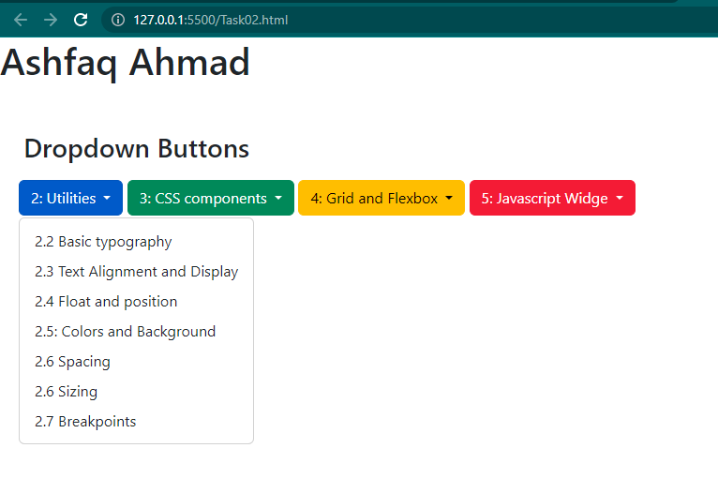

**Task 03:**

Use Bootstrap classes to create Navbar as shown below:

**Code:**

<!doctype html>

<html lang="en">

<head>

    <meta charset="utf-8">

    <meta name="viewport" content="width=device-width, initial-scale=1">

    <title>Bootstrap demo</title>

    <link href="https://cdn.jsdelivr.net/npm/bootstrap@5.3.0-alpha2/dist/css/bootstrap.min.css" rel="stylesheet"

        integrity="sha384-aFq/bzH65dt+w6FI2ooMVUpc+21e0SRygnTpmBvdBgSdnuTN7QbdgL+OapgHtvPp" crossorigin="anonymous">

    <style>

        .bar4 {

            padding: 0px 100px 0px 0px;

        }

        .bar5 {

            padding: 0px 200px 0px 130px;

        }

        .bar6 {

            padding: 0px 550px 0px 400px;

        }

        .bar7 {

            padding: 0px 0px 0px 700px;

        }

        .bar8 {

            padding: 0px 200px 0px 130px;

        }

        .bar9 {

            padding: 0px 160px 0px 80px;

        }

    </style>

</head>

<body>

    <!-- navbar 1 -->

    <nav class="navbar navbar-expand-lg bg-body-tertiary">

        <div class="container-fluid">

            <a class="navbar-brand" href="#">Navbar</a>

            <div class="collapse navbar-collapse" id="navbarSupportedContent">

                <ul class="navbar-nav me-auto mb-2 mb-lg-0">

                    <li class="nav-item">

                        <a class="nav-link disabled" aria-current="page" href="#">Home</a>

                    </li>

                    <li class="nav-item">

                        <a class="nav-link disabled" href="#">About</a>

                    </li>

                    <li class="nav-item">

                        <a class="nav-link disabled">Services</a>

                    </li>

                    <li class="nav-item">

                        <a class="nav-link disabled">Contact</a>

                    </li>

                </ul>

                <form class="d-flex" role="search">

                    <input class="form-control me-2" type="search" placeholder="Search" aria-label="Search">

                    <button class="btn btn-outline-success" type="submit">Search</button>

                </form>

            </div>

        </div>

    </nav>

    <br>

    <!-- navbar 2 -->

    <nav class="navbar navbar-expand-lg bg-body-tertiary">

        <div class="container-fluid">

            <a class="navbar-brand" href="#">Navbar</a>

            <ul class="navbar-nav topnav-right">

                <li class="nav-item">

                    <a class="nav-link disabled" aria-current="page" href="#">Home</a>

                </li>

                <li class="nav-item">

                    <a class="nav-link disabled" href="#">About</a>

                </li>

                <li class="nav-item dropdown">

                    <a class="nav-link dropdown-toggle disabled" href="#" role="button" data-bs-toggle="dropdown"

                        aria-expanded="false">

                        Dropdown

                    </a>

                    <ul class="dropdown-menu">

                        <li><a class="dropdown-item" href="#">Action</a></li>

                        <li><a class="dropdown-item" href="#">Another action</a></li>

                        <li>

                            <hr class="dropdown-divider">

                        </li>

                        <li><a class="dropdown-item" href="#">Something else here</a></li>

                    </ul>

                </li>

                <li class="nav-item">

                    <a class="nav-link disabled">Services</a>

                </li>

                <li class="nav-item">

                    <a class="nav-link disabled">Contact</a>

                </li>

            </ul>

        </div>

    </nav>

    <br>

    <!-- navbar 3 -->

    <nav class="navbar navbar-expand-lg  bg-dark ">

        <div class="container-fluid">

            <a class="navbar-brand text-white" href="#">Navbar</a>

            <button class="navbar-toggler" type="button" data-bs-toggle="collapse"

                data-bs-target="#navbarSupportedContent" aria-controls="navbarSupportedContent" aria-expanded="false"

                aria-label="Toggle navigation">

                <span class="navbar-toggler-icon"></span>

            </button>

            <div class="topnav" id="navbarSupportedContent">

                <ul class="navbar-nav topnav-right">

                    <li class="nav-item">

                        <a class="nav-link disabled text-white-50" aria-current="page" href="#">Home</a>

                    </li>

                    <li class="nav-item">

                        <a class="nav-link disabled text-white-50" href="#">About</a>

                    </li>

                    <li class="nav-item">

                        <a class="nav-link disabled text-white-50">Services</a>

                    </li>

                    <li class="nav-item">

                        <a class="nav-link disabled text-white-50">Contact</a>

                    </li>

                </ul>

            </div>

        </div>

    </nav>

    <!-- navbar 4 -->

    <div class="bar4">

        <br>

        <nav class="navbar sticky-top  bg-dark ">

            <div class="container-fluid bg-dark">

                <a class="navbar-brand text-white" href="#">Navbar Sticky Top</a>

            </div>

        </nav>

    </div>

    <!-- navbar 5 -->

    <div class="bar5">

        <br>

        <nav class="nav nav-pills">

            <a class="nav-link" href="#">Link 1</a>

            <li class="nav-item">

                <a class="nav-link active" aria-current="page" href="#">Link 2</a>

            </li>

            <a class="nav-link" href="#">Link 3</a>

            <a class="nav-link">Link 4</a>

        </nav>

    </div>

    <!-- navbar 6 -->

    <div class="bar6">

        <ul class="nav justify-content-end nav-pills">

            <a class="nav-link" href="#">Link 1</a>

            <li class="nav-item">

                <a class="nav-link active" aria-current="page" href="#">Link 2</a>

            </li>

            <a class="nav-link" href="#">Link 3</a>

            <a class="nav-link">Link 4</a>

        </ul>

    </div>

    <!-- navbar 7 -->

    <div class="bar7">

        <ul class="nav justify-content-center nav-pills">

            <a class="nav-link" href="#">Link 1</a>

            <li class="nav-item">

                <a class="nav-link active" aria-current="page" href="#">Link 2</a>

            </li>

            <a class="nav-link" href="#">Link 3</a>

            <a class="nav-link">Link 4</a>

        </ul>

    </div>

    <!-- navbar 8 -->

    <div class="bar8">

        <nav class="nav flex-column">

            <a class="nav-link active" aria-current="page" href="#">Link 1</a>

            <li class="nav-item nav-pills">

                <a class="nav-link active" aria-current="page" href="#">Link 2</a>

            </li>

            <a class="nav-link active" aria-current="page" href="#">Link 3</a>

            <a class="nav-link active" aria-current="page" href="#">Link 4</a>

        </nav>

    </div>

    <br>

    <!-- navbar 9 -->

    <div class="bar9">

        <nav class="nav nav-pills nav-justified">

            <a class="nav-link" href="#">Link 1</a>

            <a class="nav-link active" aria-current="page" href="#">Link2</a>

            <a class="nav-link" href="#">Link 3</a>

            <a class="nav-link" href="#">Link 4</a>

        </nav>

    </div>

    <br>

    <!-- navbar 10 -->

        <nav class="navbar sticky-bottom navbar-expand-lg bg-dark ">

            <div class="container-fluid bg-dark">

                <a class="navbar-brand text-white" href="#">Navbar Sticky Top</a>

            </div>

        </nav>

    <script src="https://cdn.jsdelivr.net/npm/bootstrap@5.3.0-alpha2/dist/js/bootstrap.bundle.min.js"

        integrity="sha384-qKXV1j0HvMUeCBQ+QVp7JcfGl760yU08IQ+GpUo5hlbpg51QRiuqHAJz8+BrxE/N" crossorigin="anonymous">

        </script>

</body>

</html>

**Output:**

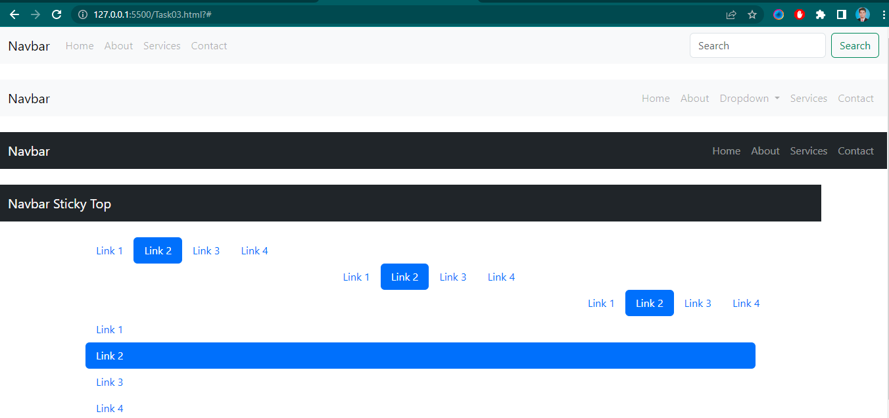 

**Task 04:**

Use Bootstrap classes to design a web page as shown below:

**Code:**

<!doctype html>

<html lang="en">

<head>

  <meta charset="utf-8">

  <meta name="viewport" content="width=device-width, initial-scale=1">

  <title>Bootstrap demo</title>

  <link href="https://cdn.jsdelivr.net/npm/bootstrap@5.3.0-alpha2/dist/css/bootstrap.min.css" rel="stylesheet"

    integrity="sha384-aFq/bzH65dt+w6FI2ooMVUpc+21e0SRygnTpmBvdBgSdnuTN7QbdgL+OapgHtvPp" crossorigin="anonymous">

</head>

<body>

<!-- navbar -->

  <nav class="navbar navbar-expand-lg bg-body-tertiary sticky-top">

    <div class="container-fluid">

      <a class="navbar-brand" href="#">Navbar</a>

      <button class="navbar-toggler" type="button" data-bs-toggle="collapse" data-bs-target="#navbarSupportedContent" aria-controls="navbarSupportedContent" aria-expanded="false" aria-label="Toggle navigation">

        <span class="navbar-toggler-icon"></span>

      </button>

      <div class="collapse navbar-collapse" id="navbarSupportedContent">

        <ul class="navbar-nav me-auto mb-2 mb-lg-0">

          <li class="nav-item">

            <a class="nav-link active" aria-current="page" href="#">Home</a>

          </li>

          <li class="nav-item">

            <a class="nav-link" href="#">Link</a>

          </li>

          <li class="nav-item dropdown">

            <a class="nav-link dropdown-toggle" href="#" role="button" data-bs-toggle="dropdown" aria-expanded="false">

              Dropdown

            </a>

            <ul class="dropdown-menu">

              <li><a class="dropdown-item" href="#">Action</a></li>

              <li><a class="dropdown-item" href="#">Another action</a></li>

              <li><hr class="dropdown-divider"></li>

              <li><a class="dropdown-item" href="#">Something else here</a></li>

            </ul>

          </li>

          <li class="nav-item">

            <a class="nav-link disabled">Disabled</a>

          </li>

        </ul>

        <form class="d-flex" role="search">

          <input class="form-control me-2" type="search" placeholder="Search" aria-label="Search">

          <button class="btn btn-outline-success" type="submit">Search</button>

        </form>

      </div>

    </div>

  </nav>

  <!-- side bar -->

  <div class="container">

    <div class="row">

      <div class="col-3">

        <h3>Some Favorites</h3>

        <ul class="nav flex-column nav-pills">

          <li class="nav-item">

            <a class="nav-link active" aria-current="page" href="#">Squid Game</a>

          </li>

          <li class="nav-item">

            <a class="nav-link" href="#">Money Heist</a>

          </li>

          <li class="nav-item">

            <a class="nav-link" href="#">The Crown</a>

          </li>

          <input class="form-control me-2" type="search" placeholder="Search" aria-label="Search">

          <li class="nav-item">

            <a class="btn btn-primary" aria-current="page" href="#">Search Movies/Series</a>

          </li>

        </ul>

      </div>

      <!-- main page -->

      <div class="col-9">

        <h1>My Blog</h1>

        <div class="container px-3 border-2 border-start">

          <p>Thank you so much for visiting.This is my Test Website. Please read my latest posts.

            <br>

            <br>

            Madeha

          </p>

        </div>

        <h1>Healthy Veggies</h1>

        <div class="container">

          <div class="row">

            <div class="col-3 border p-3">Veggies</div>

            <div class="col-9 border p-3">Nutration Facts </div>

            <div class="col-3 border p-3 bg-body-tertiary">Beets</div>

            <div class="col-9 border p-3 bg-body-tertiary">Calories: 58, Total Fat: 0.2 g Sodium: 106 mg, Total Carbohydrate: 13 g, Protien: 2.2 g, Calcium: 21.76 mg </div>

            <div class="col-3 border p-3">Carrots</div>

            <div class="col-9 border p-3">Calories: 41g, Protein: 0.9 g, Carbs: 9.6 g Fat: 0.2 g.

            </div>

          </div>

        </div>

        <br>

        <div class="card-group">

          <div class="card">

            <img src="https://media.istockphoto.com/id/584890470/photo/fresh-beetroot-isolated-on-white-background.jpg?b=1&s=170667a&w=0&k=20&c=i6FmukBq46O1wxK8wfQEk4KS1yk3vCREVsJriCtS9JY=" class="card-img-top border" alt="...">

            <div class="card-body">

              <h5 class="card-title">Beets</h5>

              <p class="card-text">What a beautiful Color!</p>

            </div>

          </div>

          <div class="card">

            <img src="https://health.clevelandclinic.org/wp-content/uploads/sites/3/2017/07/coloredCarrots-022521-LD-770x533-1-650x428.jpg" class="card-img-top border" alt="...">

            <div class="card-body">

              <h5 class="card-title">Carrots</h5>

              <p class="card-text">Eat as much as you can.</p>

            </div>

          </div>

          <div class="card">

            <img src="https://www.eatme.eu/media/ydhoq1jg/eat-me-groene-asperges-200-gram.jpg?anchor=center&mode=crop&width=1200&height=785&rnd=132629798811500000" class="card-img-top border" alt="...">

            <div class="card-body">

              <h5 class="card-title">Asparagus</h5>

              <p class="card-text">Spears, spears, spears.</p>

            </div>

          </div>

        </div>

        <h1>Important information</h1>

        <p>Lorem ipsum dolor sit amet consectetur, adipisicing elit. Ducimus maiores quae accusamus ratione harum tempora deleniti asperiores, <br><br>

        Weather Advisory: Heavy rains and thunderstorm expected: Stay Safe!

        </p>

      </div>

    </div>

  </div>

  <script src="https://cdn.jsdelivr.net/npm/bootstrap@5.3.0-alpha2/dist/js/bootstrap.bundle.min.js"

    integrity="sha384-qKXV1j0HvMUeCBQ+QVp7JcfGl760yU08IQ+GpUo5hlbpg51QRiuqHAJz8+BrxE/N"

    crossorigin="anonymous"></script>

</body>

</html>

**Output:**

